**15th International Energy Forum Ministerial Meeting**

**Background Paper by the**

**International Energy Agency**

***Algiers, 26-28 September 2016***

*The International Energy Agency submits its views on global energy trends to 2040, which were last reviewed in its* **World Energy Outlook 2015***. This outlook considers three scenarios: a* ***New Policies Scenario****, which takes into account the policies, implementing measures and pledges affecting markets adopted as of mid-2015; a* ***Current Policies Scenario****, which takes into account only policies enacted by mid-2015; and a* ***450 Scenario****, which depicts a pathway to the 2*°*C climate goal achieved with technologies that are close to being available at commercial scale. The next edition of the flagship publication will be available in November 2016. This paper also includes the latest findings from the* **World Energy Investment 2016** *report, which provides a comprehensive picture of global energy spending.*

**Global Energy Trends to 2040**

Government policies continue to play a powerful role in determining the evolution of the energy sector. World energy demand grows in all World Energy Outlook 2015 (WEO) scenarios, but government policies play a powerful role in dictating the degree of growth and the degree to which greenhouse gas emissions decouple from energy use.

Between 1990 and 2013, the world’s primary energy demand increased by 55% to 13 560 million tonnes of oil equivalent (Mtoe), and it is projected to grow by a further 45% to 2040 in the Current Policies Scenario, 32% in the New Policies Scenario and 12% in the 450 Scenario, according to the projections of WEO 2015.

In the New Policies Scenario, demand for all fossil fuels increases, but growth in coal demand stays at low levels, and natural gas use nearly reaches the level of coal by 2040. In the 450 Scenario, the consumption of fossil fuels is still far from trivial but, utilising only commercial and near-commercial technologies, global demand for both coal and oil reaches its peak by 2020 and then moves into a clear decline, while the use of natural gas levels off around 2030.

Despite efforts to decarbonise the world’s energy system, the share of fossil fuels in the global energy mix has hardly changed over the last thirty years (81% in 2013), while coal (the most carbon-intensive fossil fuel) has attained, in 2013, its highest share of the energy mix for at least 40 years.

In all WEO 2015 scenarios, fossil fuels remain the dominant source of energy supply to 2040, but their share of the energy mix falls, just slightly in the Current Policies Scenario but much more rapidly in the 450 Scenario. In the Current Policies Scenario, demand for coal overtakes oil around 2030 to make coal the largest component of the energy mix, while it is natural gas which experiences the highest growth in demand (in absolute terms) through to 2040.

The outlook for all forms of low-carbon energy (renewables, nuclear power and carbon capture and storage [CCS]) is more positive in the 450 Scenario and they collectively meet 46% of primary energy demand by 2040.

**Figure 1: World primary energy demand and CO2 emissions by scenario**

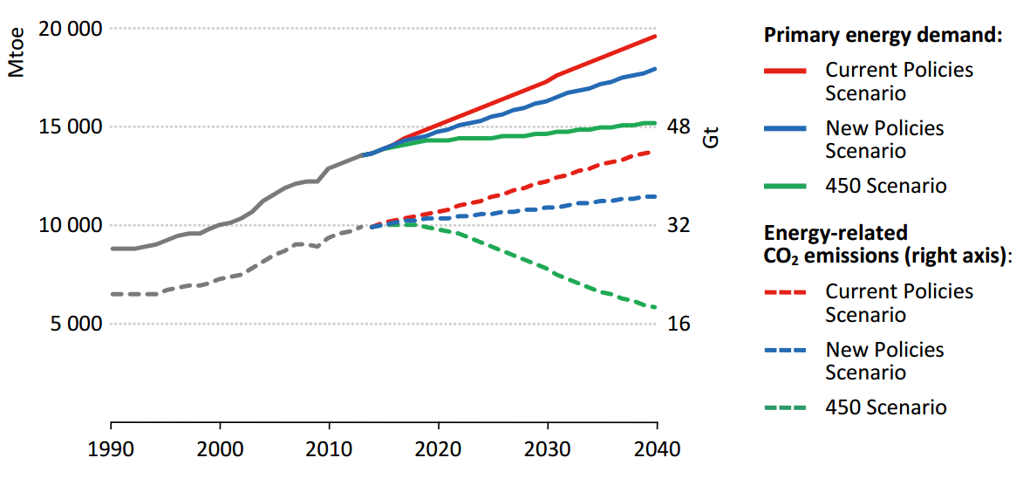

***Source: WEO 2015***

**Focus on the New Policies Scenario**

In the New Policies Scenario, global primary energy demand increases by nearly one-third between 2013 and 2040 to reach 17 900 Mtoe. The annual average rate of growth in primary energy demand slows over time: from 2.5% in 2000-2010, it falls to 1.4% in the current decade, 1% in the next and below 1% in the 2030s.

A deceleration of global economic and population growth, coupled with more robust energy efficiency and other policies all play a role, particularly the slowing of economic expansion in some key economies (such as China).

The link between economic growth and energy demand weakens over time in the New Policies Scenario, reflecting the changing nature of economic development. More markets approach a saturation point in demand for energy services and more energy efficient technologies are adopted, together with policies that allow these services to be provided more effectively.

Many economies also continue to undergo structural change, either in the form of a transition towards less energy-intensive forms of economic activity (i.e. services and light industry), such as in China, or further industrialisation, such as in India.

The world’s population has doubled in a little over 40 years and is projected to expand by one-quarter to reach nine billion people in 2040. But the weight of this growth moves away from the largest global centre of energy demand growth (Asia) and towards regions that currently have very low levels of energy use (led by Africa).

The world average of per-capita energy demand remains close to existing levels in the New Policies Scenario, but masks a large disparity across regions: low but rising in much of Asia, Latin America and others; high but declining in Canada, the United States etc. This disparity narrows only slowly over time.

Primary energy demand for all fuels grows through 2040. Of this growth, renewables collectively account for 34%, natural gas for 31%, nuclear for 13%, oil for 12% and coal for 10%.

Renewables increase significantly, but their growth only just outpaces that of total energy demand, meaning that their share of the energy mix changes little. Similarly, nuclear sees little change. By 2040, oil and coal collectively relinquish a 9% share of the global energy mix, while renewables see their share grow (by 5%), as does natural gas (+2%) and nuclear (+2%). Non-hydro renewables and natural gas see growth accelerate after 2025, while demand growth for oil slows notably over time and for coal it stays relatively low throughout the projection period.

**Figure 2: Primary energy demand and GDP by selected region in the NPS, 2015-2040**

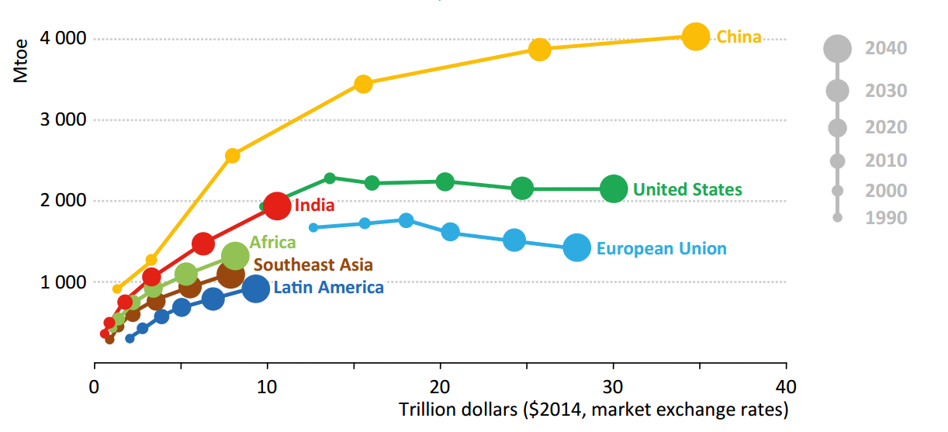

***Source: WEO 2015***

**Outlook by Fuel**

***Oil***

The process of adjustment in the oil market is rarely a smooth one, but, in our central scenario, the market rebalances at $80/bbl in 2020, with further increases in price thereafter. World oil demand increases by 15% in the New Policies Scenario, reaching 103.5 million barrels per day (mb/d) in 2040. Demand growth slows gradually over time, from an average of around 0.85 mb/d per year to 2020 to around 0.4 mb/d thereafter.

A boost to demand in the near term, stemming from low oil prices, is progressively counter-balanced by a combination of lower economic growth expectations in some key economies, the impact of efficiency and emissions policies and, over time, a rebound in oil prices reflecting a cut in capital investment by the oil industry.

In a scenario where oil prices stay lower for longer, global oil demand is 3.7 mb/d higher than the New Policies Scenario in 2040 (over 107.2 mb/d), mainly as a result of higher transport demand. Oil demand becomes even more concentrated in the transportation and petrochemical sectors.

Collectively, the United States, EU and Japan see their oil demand drop by around 10 mb/d by 2040. On the supply side, the decline in current upstream investment, estimated at more than 20% in 2015, results in the combined production of non-OPEC producers peaking before 2020 at just above 55 mb/d.

Output growth among OPEC countries is led by Iraq and Iran, but both countries face major challenges: the risk of instability in Iraq, alongside weaknesses in infrastructure and institutions; and the need in Iran (assuming the path to sanctions relief is followed successfully) to secure the technology and large-scale investment required to increase production. The current overhang in supply should give no cause for complacency about oil market security.

***Coal***

In the New Policies Scenario, global coal demand grows by around 10% by 2040, to exceed 6 300 million tonnes of coal equivalent (Mtce), reflecting the net outcome of declining or stable demand in some markets and growing demand in others. The power sector accounts for the majority of the increase in coal use and continues to account for over 60% of world coal consumption.

Coal’s share of global electricity generation drops from 41% in 2013 to 30% in 2040, but this hides a major disparity between developing Asia (where it goes from 68% to below 50%) and the rest of the world (from 27% to 13%).

The single largest energy demand growth story of recent decades is near its end. Recent years have seen a marked slowdown in global coal demand growth, led by China, and, in the New Policies Scenario, China’s coal use is projected to have all but reached a plateau that is broadly maintained through to 2040.

In the New Policies Scenario, coal demand in China’s power sector is tempered, but still increases by 14% before levelling off in the mid-2030s. This growth is offset by changes in China’s industrial coal use, which falls by more than 35% by 2040.

India’s appetite for coal leads the growth picture, both in the region and globally, and it soon overtakes the United States to become the world’s second-largest consumer. India’s industrial sector sees coal demand more than triple by 2040, reflecting a greater focus on the industrialisation of its economy. Southeast Asia, led by Indonesia, but also Viet Nam, Philippines and Malaysia, sees total coal demand more than triple over the projection period.

By 2040, Asia is projected to account for four out of every five tonnes of coal consumed globally. In contrast, coal demand declines in almost all OECD regions. Coal demand in the United States peaked in 2005 and has since fallen by more than one-fifth. This trend continues in the New Policies Scenario, as the United States registers one of the largest drops in demand over the Outlook period, with consumption ending more than one-third lower in 2040 than in 2013.

***Natural Gas***

In 2014, natural gas markets continued to demonstrate significant diversity across regions, with strong natural gas demand in the United States, the Middle East and China, and a weak market in Europe.

In the New Policies Scenario, the global market for natural gas expands by 47% to reach 5 160 billion cubic metres (bcm) in 2040, registering steady growth of around 1.4% per year and coming close to rivalling coal as the second-largest fuel in the energy mix.

In almost all regions, power generation is the largest use of natural gas and the main driver of demand growth, although natural gas is also used more extensively in industry in some markets (Middle East, China) and starts to make a dent in road transport in some cases.

Despite this, the global outlook for natural gas is a little less golden than during the previous review – around 220 bcm lower in 2040 – reflecting a combination of efficiency policies, more sluggish electricity demand in some (mainly OECD) markets and its ongoing rivalry with other fuels and technologies.

***Renewables***

In the New Policies Scenario, renewables meet around 35% of the total growth in primary energy demand, driven by a combination of supportive government policies and technological advances that help to improve their competitive stance.

By 2040, renewable energy accounts for one-third of total electricity generation, one-sixth of heat demand and more than 5% of all transport fuel consumption. Biofuel blending mandates are now in place in around 60 countries and, in the New Policies Scenario, demand for biofuels in transport is projected to triple over the Outlook period, exceeding 4 mboe/d by 2040.

The United States (targeting 36 billion gallons of renewable fuels by 2022), Brazil (biofuel blending mandate recently increased to 27%) and the European Union (targeting 10% of transport energy from renewable sources by 2020) continue to be the key markets for biofuels -- all of them more than double in size by 2040 -- with China and India also expanding the use of biofuels over time.

In 2040, the consumption of bioenergy for cooking and heating still accounts for a large share of the use of renewable energy in the buildings sector (especially in Africa and parts of Asia), with the electricity consumed from rooftop solar photovoltaics (PV) a noteworthy complement.

***Electricity***

The world continues to electrify, with electricity demand growing by more than 70% by 2040. Non-OECD markets account for more than 85% of the growth, led by China (one-third of the global increase), followed (some way behind) by India, Southeast Asia, Africa, the Middle East and Latin America.

The European Union and Japan both see electricity use grow by less than 10% to 2040. Total non-OECD electricity demand is double that of the OECD countries by 2040, but per-capita demand remains much lower in most cases. The means by which electricity demand is met is covered in subsequent sections.

**Figure 4: Primary energy demand by fuel in the NPS**

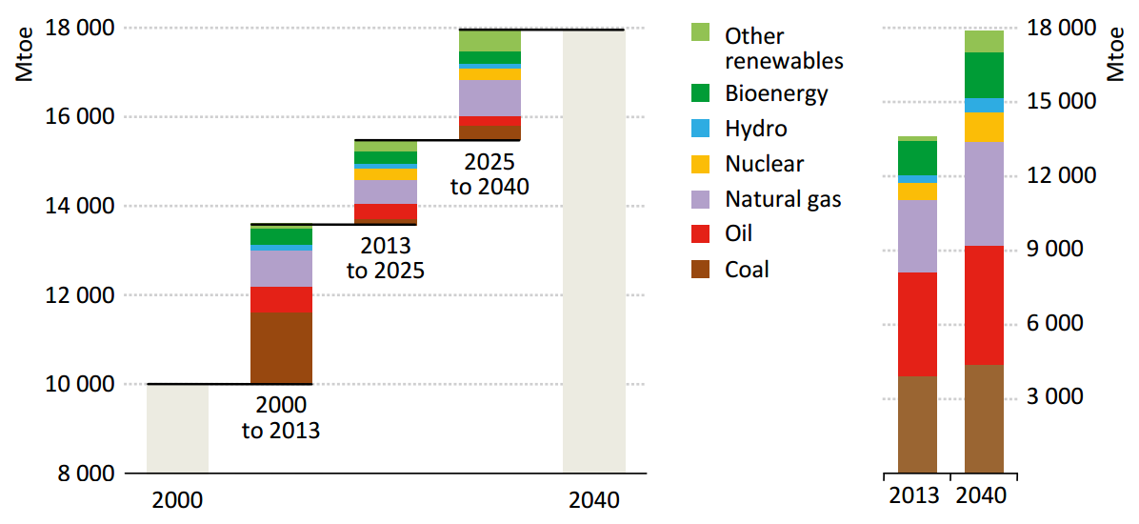

***Source: WEO 2015***

**World Energy Investment 2016**

The upstream oil and gas sector continues to attract the biggest share of global energy investment, but the energy system is also undergoing a broad reorientation toward low-carbon energy and efficiency, according to the IEA’s recently released [*World Energy Investment 2016*](http://www.iea.org/bookshop/731-World_Energy_Investment_2016) report.

Investment in key clean energy technologies needs to be further ramped up to put the world economy on track for climate stabilisation. It also shows that government policies are key to a successful energy transition. While some progress has been achieved, investors need clarity and certainty from policy makers.

Global energy investment amounted to USD 1.8 trillion in 2015, making up 2.4% of global GDP.Investment in real dollar terms was 8% lower than in 2014, mainly due to a 25% fall in capital spending in upstream oil and gas.

**Figure 5: Global investment in energy supply over time**



***Source: World Energy Investment 2016***

The oil and gas sector remained by far the largest recipient of investment, accounting for 45% of total energy investment.The upstream sector alone absorbed more than USD 580 billion – almost one-third of the total – and the rest of oil and gas sector USD 250 billion, or 14%. Coal mining and infrastructure investment was USD 70 billion, or 4%.

Investment costs in 2015 declined across the energy spectrum, heavily in some cases, moderating the impact from capacity additions.

One of the most significant facts of the past two years is the decline in global upstream investment, which fell dramatically following the oil price collapse in the second half of 2014. The drop amounted to 25% in 2015 and 24% in 2016 based on current plans. The total fall exceeded USD 300 billion over the two years – an unprecedented decline. In fact, it’s the first time in 40 years that the industry experienced two consecutive years of reduced upstream spending.

And there are no signs that companies plan to increase their upstream capital spending in 2017. Many operators revised their 2016 capital spending guidance throughout the year. As of September 2016, they planned to maintain or even lower their 2017 investment compared with 2016 as they take advantage of the sector’s declining costs and gains in efficiency.

**Figure 6: Upstream oil and gas investment 2010 - 2017**



*Source: World Energy Investment 2016*

In fact, costs in the upstream oil and gas sector fell on average by 15% last year, negating some of the decline in dollar spending. Initial data point to further cost deflation in 2016. Big differences in the pace of cost declines across sectors and technologies are reshaping inter-fuel competition. (Cost reductions in the renewable sector were comparable though varied greatly by technology, with onshore wind costs falling 3% and utility solar photovoltaic costs by 19%.)

The vast majority of oil and gas upstream investment was directed at replacing natural production declines while almost 40% of electricity investment was directed to the replacement of ageing assets. As a result, the investment needed to maintain supply security is only weakly affected by changes in demand growth.

Investment in power generation totalled USD 420 billion, of which renewables accounted for nearly 70% in 2015.Investment in transportation and distribution networks was USD 460 billion, with the majority – USD 260 billion – going to electricity and USD 195 billion to pipelines and LNG facilities. Coal, nuclear, renewable heat and biomass accounted for the rest of supply-side investment.

About USD 220 billion, or 12%, was invested into energy efficiency**.** Just over half of that was spent on improving building efficiency including household appliances, an area where the increasing coverage of regulatory standards is curbing demand growth in mature markets. Spending on efficient transport increased to over USD 60 billion. While the impact of low oil prices on new vehicle efficiencies was noticeable, it did not derail the trend towards better fuel economy.

Renewable energy investments of USD 313 billion accounted for nearly a fifth of total energy spending last year, establishing renewables as the largest source of power investment. While spending on renewable power capacity was flat between 2011 and 2015, electricity generation from the new capacity rose by one third, reflecting the steep cost declines in wind turbines and solar PV. The investment in renewable power capacity in 2015 generates more than enough to cover global electricity demand growth.

Investment in new capacity to meet rising demand is declining as a share of the total with a deceleration of energy demand growth – primarily the result of declining energy intensity and slower growth, especially in China.

A structural shift towards services and rapid improvements in energy efficiency kept China’s energy demand down. India was the only major economy where accelerating economic growth boosted energy demand. Loose monetary conditions and low interest rates continued to support investment across the energy system.

With energy supply spending of USD 315 billion, China was once again the world’s largest energy investor in 2015 thanks to robust efforts in building up low-carbon generation and electricity networks, as well as implementing energy efficiency policies.

Investment in the United States’ energy supply declined to about USD 280 billion in 2015, falling by nearly USD 75 billion, due to low oil prices and cost deflation, representing half of the total decline in global energy spending. The Middle East and Russia emerged as the most resilient regions to spending cuts, thanks respectively to lower production costs and currency movements. As a result, national oil companies accounted for 44 percent of overall upstream investments, an all-time high.

Technology innovations boosted investment in smart grids and storage, which are expected to play a crucial role in integrating large shares of wind and solar. While grid-scale battery storage investment expanded tenfold since 2010, their value is predominantly to complement the grid, which continues to absorb much larger investment.

Global gas-fired power generation investment declined by nearly 40%. Asian markets continued to favour investment in coal power. Investment activity in European gas power remained muted despite large retirements anticipated in the next decade.

With investment rising 6%, energy efficiency spending was robust in 2015 due to government policies such as minimum standards that cover a rising share of new buildings, appliances and motor vehicles. In certain countries, lower oil prices slowed the trend towards more fuel-efficient vehicles, most notably in the United States where the rate of improvement in efficiency was two-thirds lower than that in recent years.

Globally, energy investment is not yet consistent with the transition to a low-carbon energy system envisaged in the Paris Climate Agreement reached at the end of 2015. While wind, solar PV and electric-vehicle investments are broadly on a trajectory consistent with limiting the increase in global temperature to 2°C, investment in other low-carbon technologies is falling behind. In several countries, nuclear capacity is ageing with little investment going to replacement capacity, and renewables are struggling to compensate for reduced nuclear output.

Large-scale investment in carbon capture and storage (CCS) has yet to take off. On the demand side, economically viable alternatives to oil have yet to emerge in aviation, heavy duty transport and shipping, which collectively account for the bulk of oil consumption. And large investments are still being made in highly inefficient subcritical coal plants, which risk locking in carbon emissions for decades. A combination of accelerated technological innovation and an investment framework aimed at encouraging rapid, large-scale deployment of low-carbon technologies will be essential to steer the transformation of the energy system in a timely way in order to jointly achieve climate and energy security objectives.